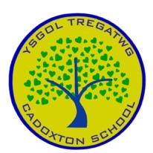
THE PROCESS OF CURRICULUM DESIGN AT CADOXTON PRIMARY SCHOOL
Our school vision was created over a period of two years in consultation with practitioners, learners, parents, carers, external agencies, and the wider community. The school has held a self-evaluation INSET day with all staff and governors to review our current curriculum offer and co-design our new adopted curriculum. This was shared for feedback with the school community and local community through a variety of communication methods including forums with parents, governing body meetings and feedback from pupils and professional learning meetings with staff. Our school vision was launched in September 2022 and underpins all areas of school life.
Our curriculum enables us to realise our vision. As part of curriculum design:
- Our school leaders and teachers undertook reading and research and attended professional learning on curriculum and curriculum design.
- We have worked with curriculum pioneers and regional consortia to seek out expert advice and support.
- Our school community agreed key features of our school context to inform the approaches and experiences best suited for the needs of all learners at our school and our approach to the four purposes.
- Through questionnaires and meetings, all governors, staff, parents and pupils were asked to consider what all pupils should know and be able to do, and which values they should develop during their time at the school.
- All staff worked together to identify the required changes to our current cultures, provision and practices.
- Teachers have worked with staff from the cluster schools to support one another in planning our curriculum and ensuring progression along the 3-16 continuum.
- We regularly share information with parents/careers on the curriculum and ways they can support their child within and outside of the school environment (E.g Celebrations of learning -parent meetings and performances of understanding).
- We collaborate and consult with a range of providers from the local and wider community on providing learners with distinct and enriching experiences including related to religion, values and ethics (RVE) and careers and work-related experiences (CWRE).

Below is a summary of questions considered by all stakeholders when designing our curriculum:

INTENT – WHY?
What are the long-term goals and aspirations for the children in our school?
How will we promote your vision and values?
How will we ensure that the Four Purposes are fully embedded in the life of the school?

INNOVATION – HOW?
How confident are we at implementing the pedagogical principles?
How will we experiment with innovative pedagogies and practice?
What will the ‘products’ of learning be?
What will professional learning look like?

IMPLEMENTATION – WHAT?
What learning experiences will all children have opportunities to participate in?
How will the What Matters statements be brought to life in a developmentally appropriate way?
What are the enduring understandings children will have when they leave us?

IMPACT – SO WHAT?
How will we know if we have been successful?
What systems and procedures will help us to reflect and evaluate our provision and practice?
How can classes/phases/schools work together to seek support and share successes?

The curriculum meets the required elements of the Curriculum for Wales Framework.

The four purposes and the integral skills are the WHY of our curriculum offer.
Principles for curriculum design and pedagogical principles are the HOW of our curriculum offer.
The six AoLEs, cross-curricular skills and cross-cutting themes are the WHAT of our curriculum.

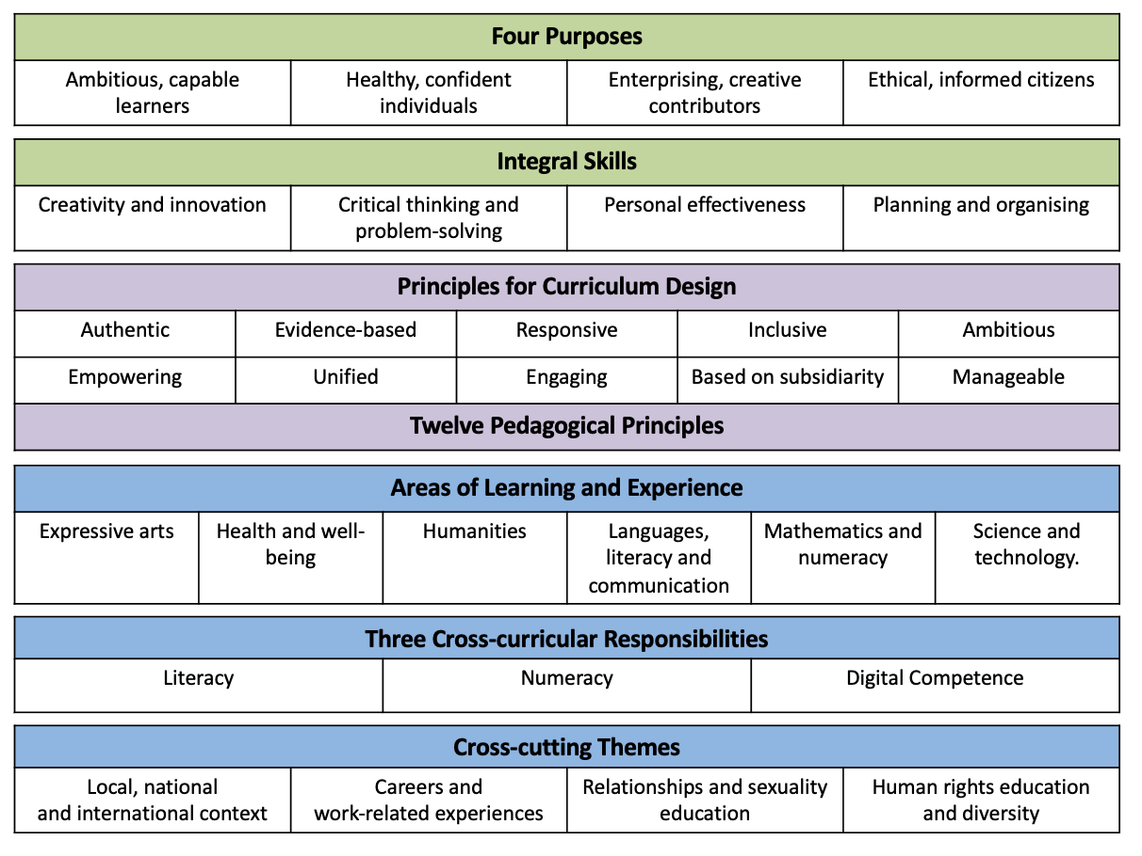
WHY?
HOW?
WHAT?
At Cadoxton Primary the curriculum is designed to:
- nurture sincere relationships with children, their families and the wider community
- provide first-hand, rich authentic learning experiences which ensure that learners’ individual needs are met
- support high levels of mental, emotional, social and physical well-being
- capture children’s natural curiosities and wonderings by using their interests as a vehicle for learning
- encourage high levels of independence and engagement in our curriculum offer
- promote a growth mindset where children recognise the importance of sustained effort and learn from their mistakes
- celebrate the diverse community in which we live and work
- To be committed to promoting diversity, equity and inclusion embedding the rights of the child (UNCRC) into our curriculum design

Our curriculum (The Cadoxton Way) supports children in being and becoming:
- Healthy, confident individuals
- Ethical, informed citizens
- Ambitious, capable learners
- Enterprising, creative contributors

Our Cadoxton Way teachers’ children the skills of how to learn by using the integral skills:
- Planning and Organising
- Critical Thinking and Problem solving
- Personal Effectiveness
- Creativity and Innovation

Our Cadoxton Way is built on Relationship Development and our mission and habits are committed to this approach.
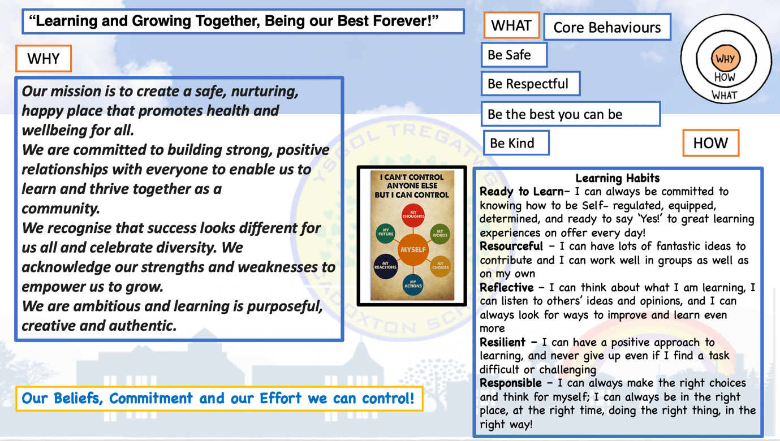

At Cadoxton Primary School, we lay the foundations for lifelong learning and value every child’s capacity to be the best they can be!

Through effective collaboration we are committed to being community schools by:
As a Pencoedtre Learning Community cluster we have a commitment to be
ASPRIATIONAL – RESPECTFUL – INCLUSIVE, to work together to have a clear vision for our community and how we meet our needs.
To have a set of principles that guide our shared curriculum approach committed to embodying the four purposes.
To be in partnership with relevant multiple agencies and our local businesses to commit to a joined-up approach to meeting the needs of our community.
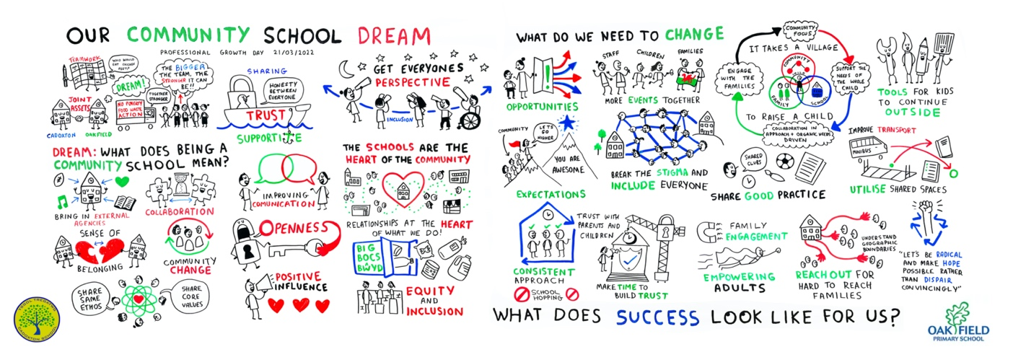

Our Curriculum Model
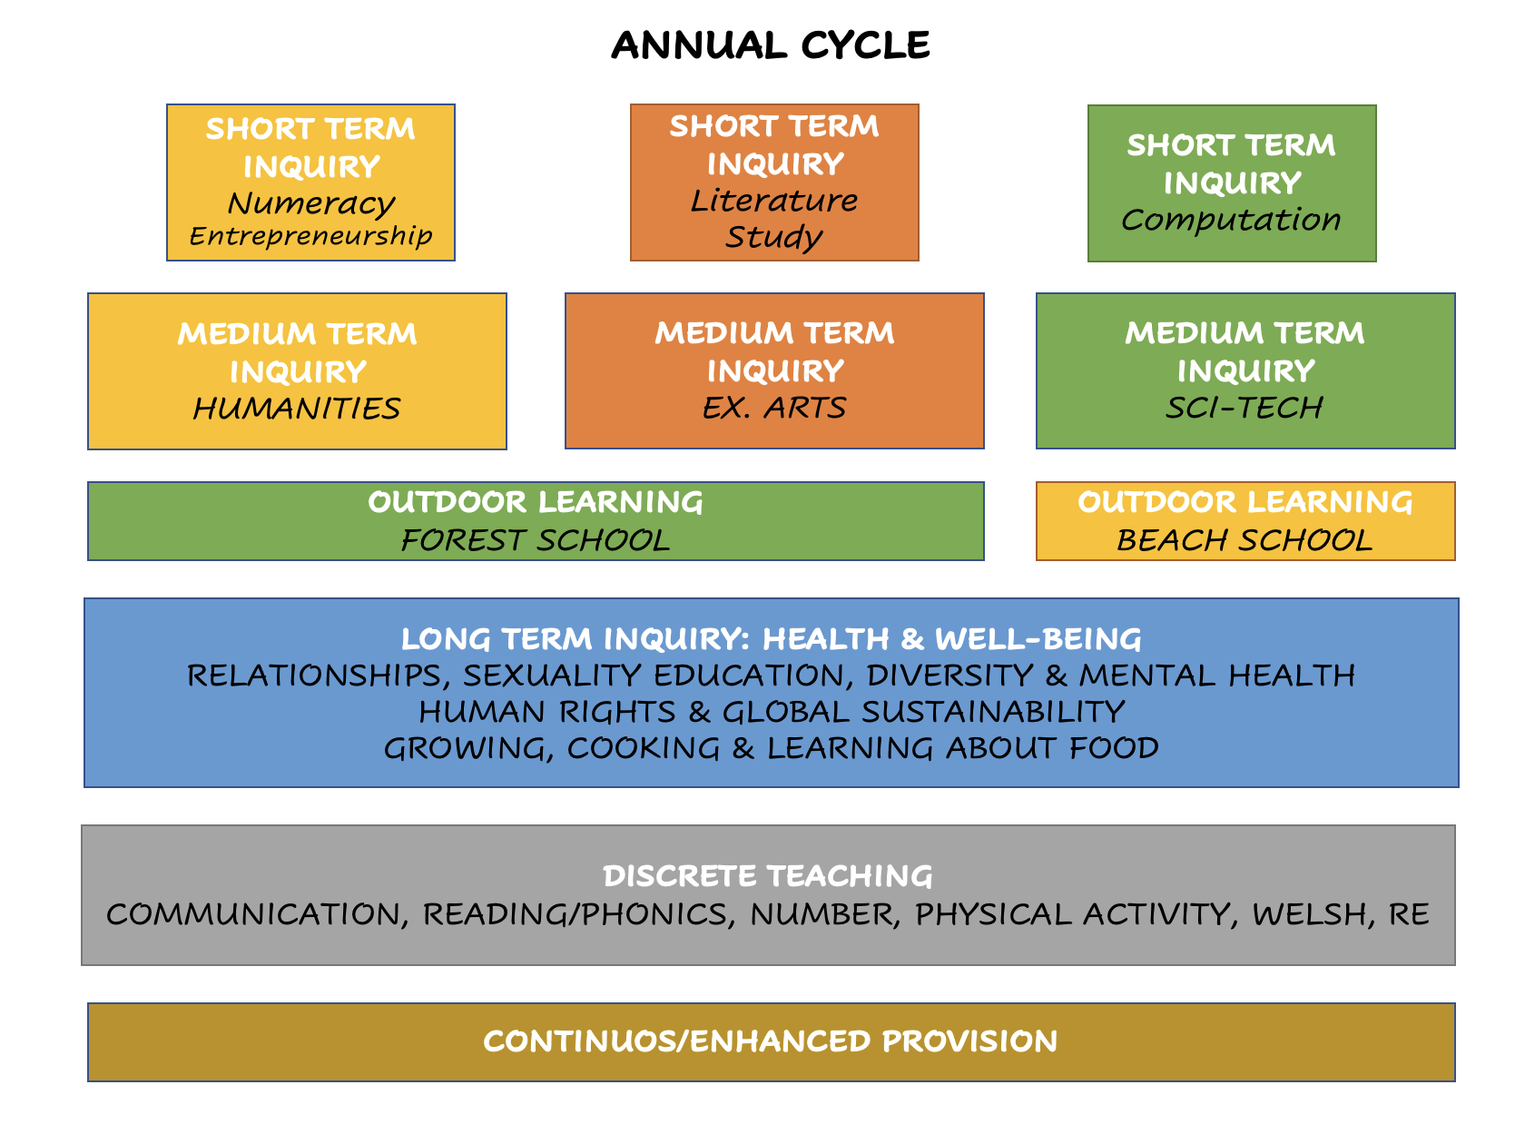
PS2 & 3
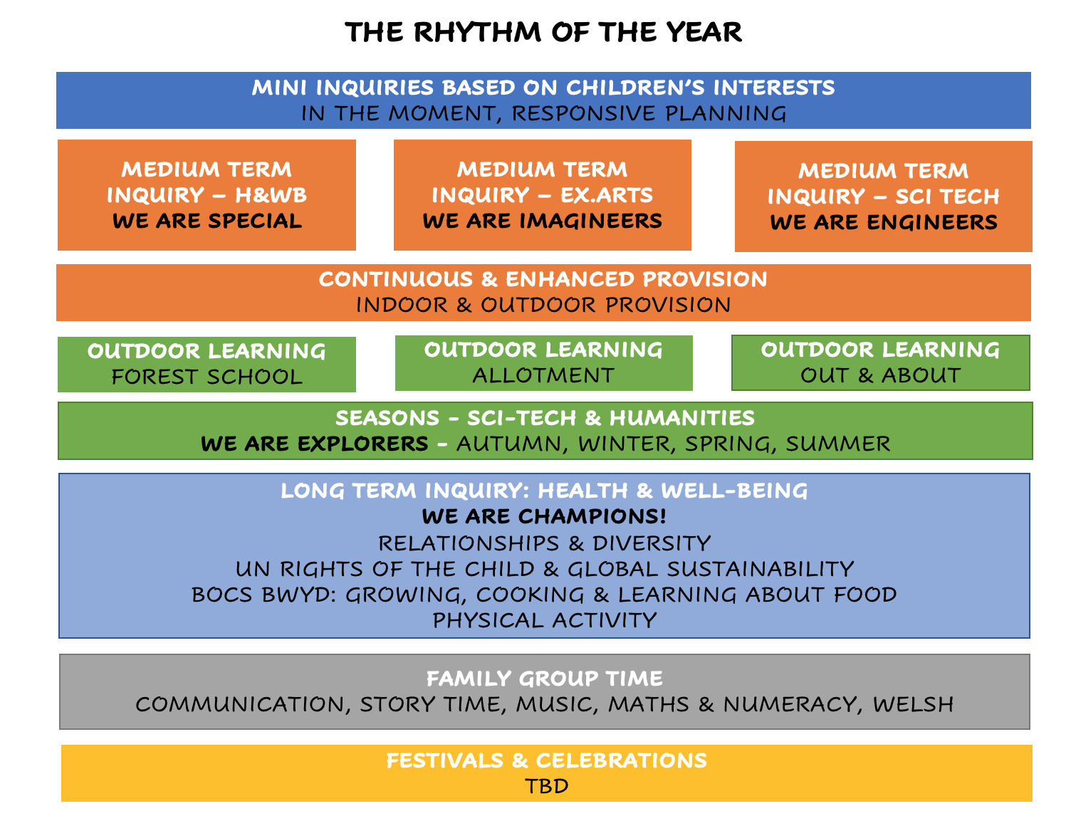
PS1
At Cadoxton Primary our key pedological approach is Inquiry-based learning approach, this enables our children to:

- Have the opportunity to find out things for themselves, they become committed to their own personal learning.
- Develop transferable skills including critical thinking, planning, self-management, organisation and communication.
- Engage children in real world questions and problems through authentic contexts.
- Develop agency. Where they gain a sense of control and responsibility for themselves as a learner: ‘Learning to learn’

Our medium-term inquiries:

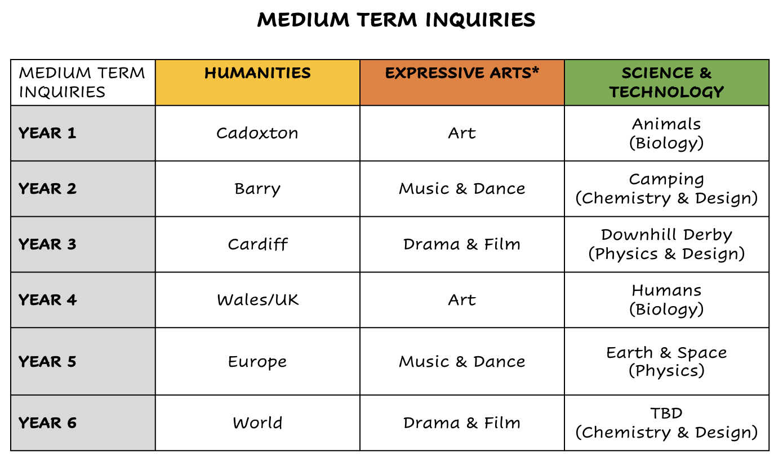
Cadoxton’s approach to progression and assessment:

AoLEs | PRINCIPLES OF PROGRESSION
Expressive Arts  Health & Well-being  Humanities  Languages, Literacy & Communication  Science and Technology | Increasing breadth and depth of knowledge | Deepening understanding of the ideas and disciplines within Areas | Refinement and growing sophistication in the use and application of skills | Making connections and transferring learning into new contexts | Increasing effectiveness as a learner
Mathematics & Numeracy | Conceptual understanding | Communication using symbols | Fluency | Logical reasoning | Strategic competence

As part of our assessment of learners’ progress, we are continuing to:

- Use ongoing classroom assessment to support learners 3-11 to make effective progress throughout the curriculum. This includes supporting progress in literacy, numeracy and digital competency (using the Literacy and Numeracy Framework and Digital Competence Framework - https://hwb.gov.wales/curriculum-for-wales/cross-curricular-skills-frameworks/#literacy-and-numeracy-framework)

Personalised assessments:

Learners in Years 2-6 take personalised assessments in Reading, Numeracy (Procedural) and Numeracy (Reasoning) in accordance with 'National Reading and Numeracy Personalised Assessments: administration handbook 2021 to 2022. These statutory assessments are taken in December and June during each academic year and are used by teachers to support learning, teaching and progression.

Assessment for Learning:

We use assessment for learning (AFL) to give children feedback that they can use to progress their learning. Assessment for Learning aims to close the gap between children’s current attainment and where they want to be in their learning. Our teachers use regular opportunities to enable this feedback to take place. AFL involves our children becoming more active in their learning and starting to ‘think like a teacher’. They think more actively about: Where they are now, Where they are going and How to get there.

Formative Assessment at Cadoxton:

What do we do? | Why do we do it?
We plan children’s learning on Building Blocks using the:  - Descriptions of Learning from Curriculum for Wales (AoLEs)  - Cross-curricular Skills Framework 2022 (Progression Steps). | To ensure that children have access to a rich, authentic curriculum offer in line with Curriculum for Wales.
We reflect on skills covered and then we assess children against the continuum:  - Emerging  - Developing  - Secure  - Mastered | To track children’s progress within Progression Steps.
We provide opportunities for self and peer assessment. | To create a learning ethos that is supportive of growth mindset and continuous improvement.
We engage in learning conversations with children. We provide opportunities for self and peer assessment. | To ensure that children know what they do well and what they need to do to get even better.
We use formative assessment to inform future planning. | To ensure that assessment informs future planning and that the need of individuals and groups of children are fully met.
We monitor curriculum coverage using Building Blocks and our Inquiry planners. | To be confident that the school’s bespoke curriculum satisfies statutory responsibilities.
We use the progress over time report to track the progress of:  - Individuals  - Groups  - Classes  - Year group cohorts | To identify children who are not making expected progress.

Formative Assessment at Cadoxton:

What do we do? | Why do we do it?
We use a range of summative assessments as to monitor learner progress:  - Salford Reading Tests  - SWST (Spelling)  - WG Personalised Assessments - Mathematical Reasoning, Procedural Mathematics and  Reading | To provide summative ‘health checks’ at specific points in the year.  To provide teachers and partner professionals with standardised assessment data.  To support  To compare standardised assessment with teacher assessment.
We compare formative and summative assessment outcomes and identify differences. | To validate teacher assessments.  To identify learners who might otherwise ‘slip through the net’.  To raise questions about individual/groups of learners.
We moderate with other schools | To ensure consistency of teacher assessments across and between schools.
We hold termly learning conversations with children and their parents. | To ensure that parents/carers are kept informed of children’s progress and know what they can do to support their child’s learning.

Under review:
The curriculum will be kept under review to ensure that it is meeting the needs of all our learners and reflects our school vision. Throughout the year there will be a variety of self-evaluation activities to inform our understanding of the effectiveness of our curriculum and any revision of this that may need to be undertaken. We will get feedback from all stakeholders including our children and parents. This is also included within our annual cycle of school development planning and evaluation. We will continue to work within our school, across our cluster and in partnership with governors, Vale of Glamorgan local authority and Central South Consortia to further develop a high-quality continuum of learning for all.

Our curriculum was formally adopted by the governing body in June 2022.

