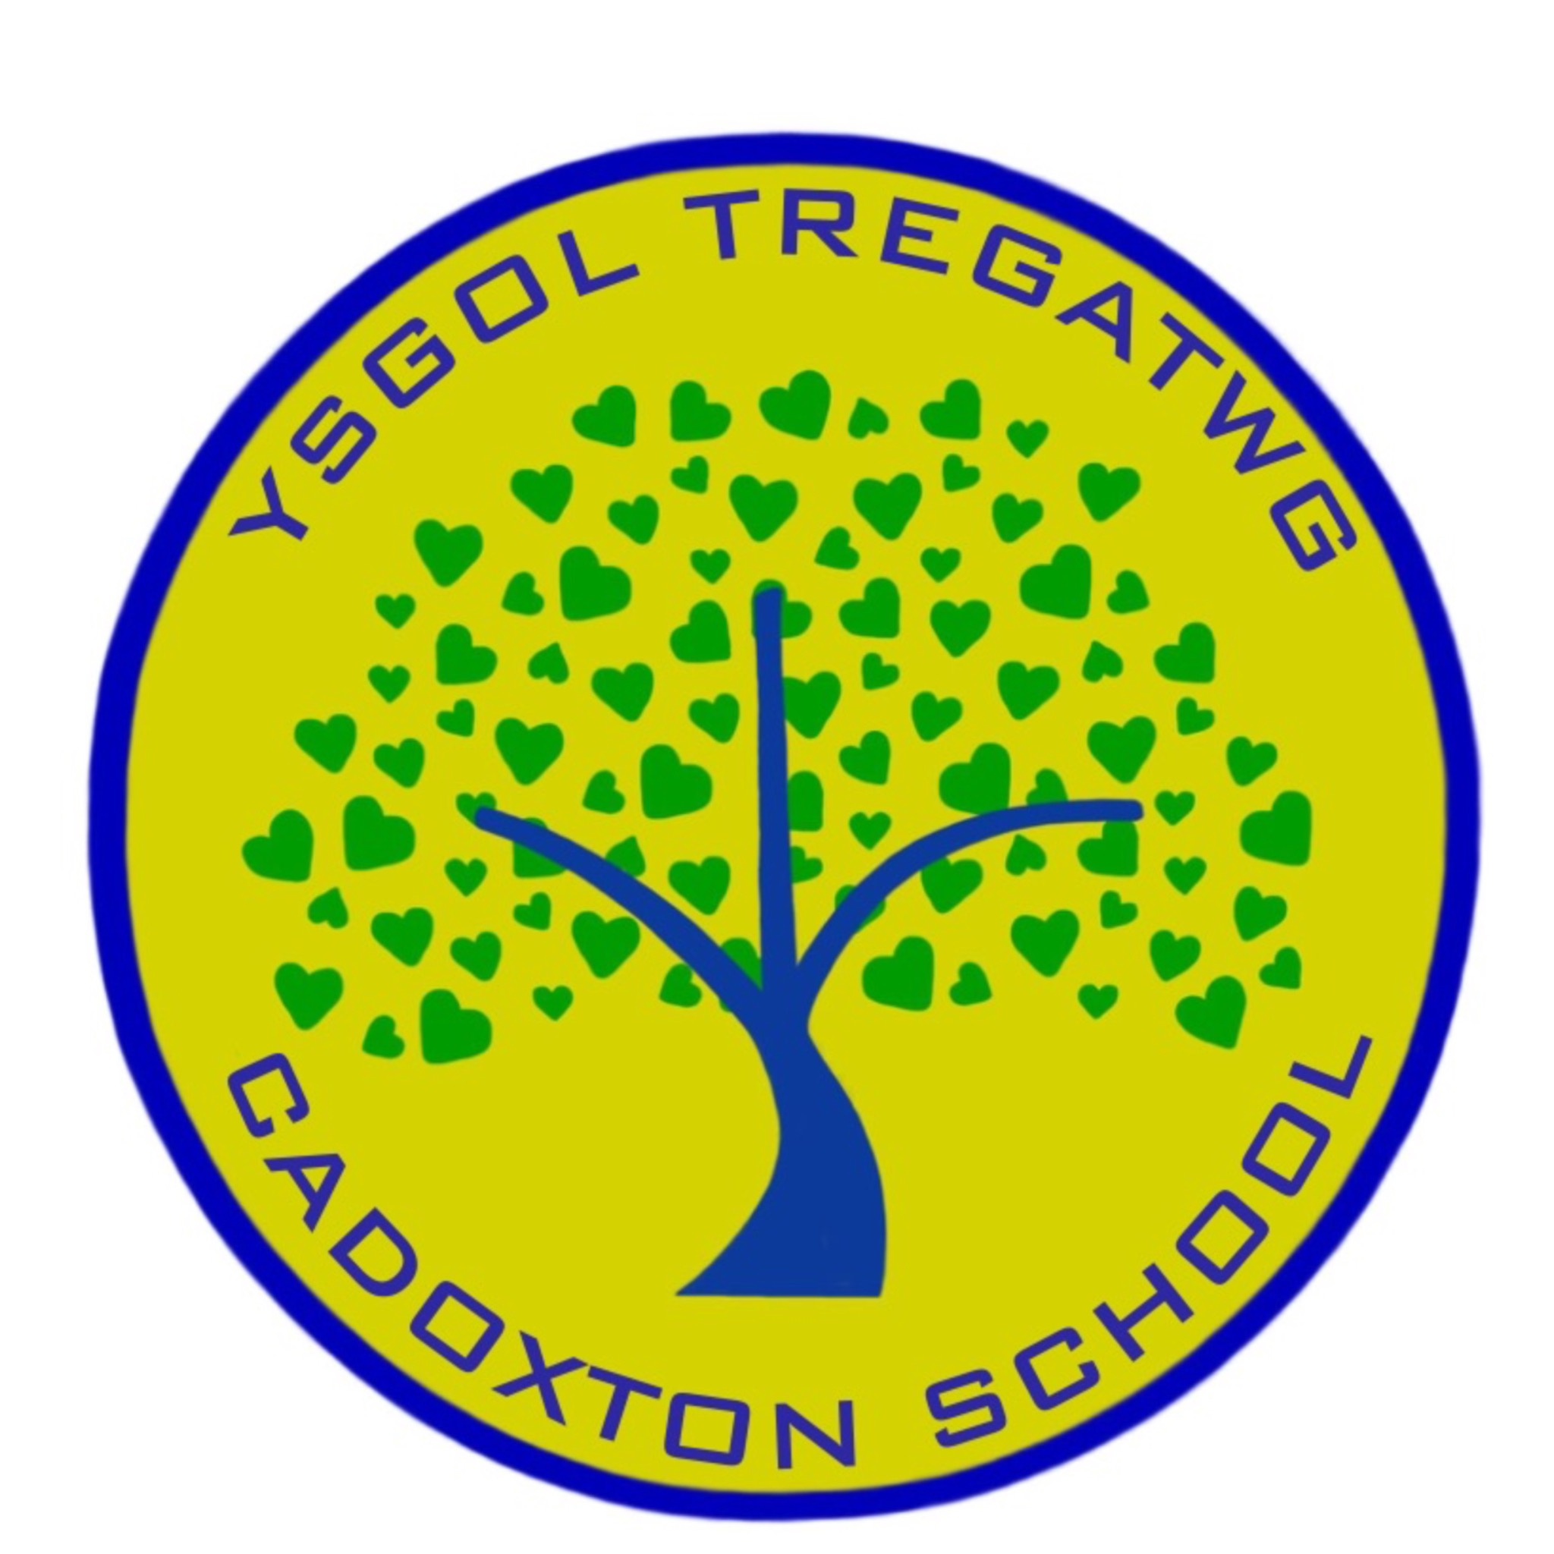

GOVERNING BODY REPORT TO PARENTS,

NOVEMBER 2023
The Governing Body of Cadoxton Primary School is pleased to present their annual report to parents. We are very proud of our Cadoxton Primary School and strive to do the best for every child every day. If any parent would like to meet with myself or any of the Governing Body, please feel welcome to contact me c/o the school. If enough parents contact me then we will hold a General Meeting.

With best wishes,

Cofion gorau,
Megan Merrett
Chair of Governing Body
Current Membership
Mrs M Merrett Chair/Parent Governor until 11/9/26
Mrs J Hayward Executive Headteacher
Mrs R Milton Head of School
Miss H Cogbill Teacher Governor until 1/9/25
Mrs L Powell Non Teaching Governor until 1/9/25
Mr R Jones Minor Authority Representative until 11/11/24
Mrs R Nugent-Finn LEA Governor until 16/10/25
Cllr C Iannucci LEA Governor until 1/9/26
Mr Dennis Clarke Co-opted Governor until 1/5/27
Mrs Wendy Thomas (Vice Chair) Co-opted Governor until 3/10/25
PSCO Dom Bury Co-opted Governor until 19/7/25
Mrs J Commrie Co-opted Governor until 26/10/27
Mrs C Harris Parent Governor until 6/10/25
Ms E Hannah Parent Governor until 11/9/26
Mr A Speight Parent Governors until 19/10/27
Clerk to Governors: Mrs Rachel Cox c/o School
School Development Plan

During March we conducted a thorough self-evaluation of all aspects of school life. Questionnaires were sent to parents and completed by children. Reviews of curriculum areas were conducted by teaching staff, and all staff reviewed the information as well as data trends, etc. All of this information was pulled together during an INSET day including Governors, members of the Parent Council and pupil Action Group leaders. As an outcome we identified a plan for ongoing development.

The Development Plan is illustrated here:

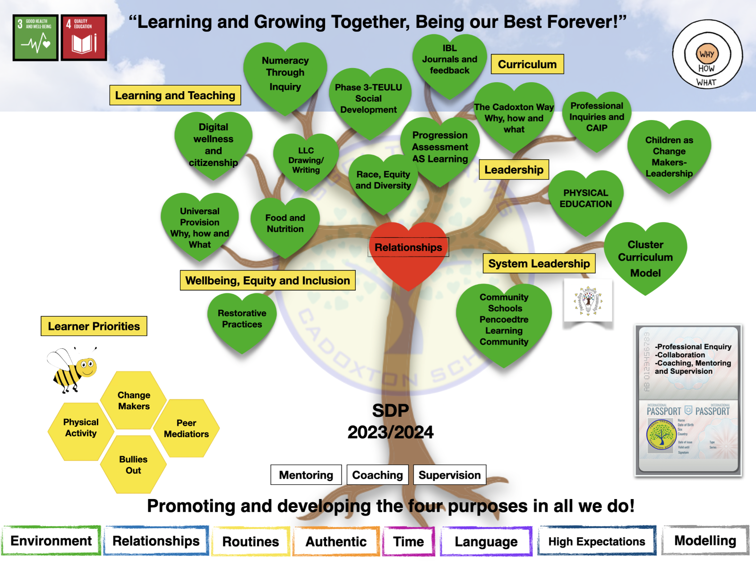

The Curriculum and Provision for Additional Learning Needs
The curriculum provided at Cadoxton Primary School is aligned to the ambition of Welsh Government’s Curriculum for Wales which seeks to secure every child as:
- An ambitious capable learner
- A healthy, happy, confident individual
- An ethical, informed citizen
- A creative, enterprising contributor.
Cadoxton Primary School is seen to be innovative in its approach in achieving this for all children. Every learning experience seeks to achieve these aims, preparing our children to be “the very best they can be”. Cadoxton Primary is an inclusive school and staff strive to provide the children identified as having barriers to their learning, with a happy, supportive and fulfilling education that enables them to reach their potential as learners.

Welsh

The Welsh language is taught discretely, within lessons and the school day through incidental use. It is also promoted by our “Criw Cymraeg” action group. We have achieved the Gold Standard “Siarter Iaith” in recognition of our excellent work with the Welsh language.

Pupil Attendance
Attendance figures for the academic year 22/23 was 91% which is lower than years prior to the COVID pandemic. This is in line with other schools in Wales due to a few reasons. It is crucial that children attend every day if possible. We know this is how children thrive and can be the best they can be, we thank parents for working with us.
Where problems occur and attendance falls, we speak with parents. When attendance falls below 80% and there is no obvious reason, we work with the Vale of Glamorgan Educational Welfare Officers (EWO). Governors also review the policy for parents wishing to take their children on holiday during term time. Any parent wishing to do this should speak to Mrs Milton before booking a holiday. Holidays will be authorised as long as attendance is good (above 94%) during the school year and if they are for less than 10 school days. For holiday dates during this school year, please see Appendix 1.
Healthy Schools
The school recognises that children need to be healthy and happy to flourish and be their best. The school has been awarded the Wales Healthy School Quality Network Award for the third time. The Governing Body have strongly supported the provision of the highest quality breakfast and dinners for pupils and this year have supported the school in a substantial investment in the refurbishment of the school dining hall.

Sporting engagement

Sporting activity and Physical Literacy are an important part of the Healthy Schools agenda. All children access plenty of opportunities during curriculum time to be active. The school also provides several afterschool sports clubs.

Toilets
There are an adequate number of toilets for the children. The toilets are monitored throughout the day by staff and cleaned to a high standard daily. We are grateful to our cleaning staff, who do a super job.

Community Links
This area is a real strength of our school and is developing all the time. Strengthening links with parents is key to our work as a school. Family learning continues to grow, and Cadog’s Corner has continued to be successful in grant applications and benefitting the school and wider community. The Community Centre hosts several opportunities for families, including Food and Fun over the Summer holidays. The school has also led work with the Pencoedtre Cluster of Schools through the year.

Year 6 Transfer
The following numbers of children transferred to High School in July:
Pencoedtre: 41
St Richard Gwyn:16
Whitmore:2
Aberdare:2
Financial Statement Please see Appendix 2 (No members of the Governing Body claimed travel or subsistence costs).
Appendix 1 – Term Dates 2023/2024
INSET Days 2023-2024
4/9/23
5/9/23
27/10/23
22/12/23
15/3/24
22/7/24
All schools will be closed on Monday 6 May 2024 for the May Day Bank Holiday.
Significant dates:
Christmas: Monday 25 December 2023
Good Friday: 29 March 2024
Easter Monday: 1 April 2024
May Bank Holidays: Monday 6 May 2024 and Monday 27 May 2024

Start: Monday 4 September 2023
Half Term: Monday 30 October - Friday 3 November 2023
End: Friday 22 December 2023
No. of School Days:75
Spring 2024

Start: Monday 8 January 2024
Half Term: Monday 12 February - Friday 16 February 2024
End: Friday 22 March 2024
No. of School Days: 50
Summer 2024

Start: Monday 8 April 2024
Half Term: Monday 27 May - Friday 31 May 2024
End: *Monday 22 July 2024
No. of School Days:70

Appendix 2
Financial Outturn 2022/23
COST CENTRE CODE | COST CENTRE DESCRIPTION | DETAIL | ANNUAL BUDGET | TOTAL ACTUAL
101025 | Cadoxton Primary School | CONT. TO FUNDS | 4,765.00 | 50,516.81
101025 | Cadoxton Primary School | CONT TO CAPITAL OUTTURN |  | 47,407.48
101025 | Cadoxton Primary School | CONT TO GENERAL RESERVE | 4,765.00 | 3,109.33
101025 | Cadoxton Primary School | EMPLOYEES | 2,335,297.00 | 2,384,701.05
101025 | Cadoxton Primary School | TEACHING EMPLOYEES | 1,164,020.00 | 1,168,713.90
101025 | Cadoxton Primary School | NON TEACHING EMPLOYEES | 463,681.00 | 485,468.99
101025 | Cadoxton Primary School | GRANT EMPLOYEES | 707,596.00 | 731,068.16
101025 | Cadoxton Primary School | OTHER DIRECT EMPLOYEES |  | (550.00)
101025 | Cadoxton Primary School | INTERNAL RECHARGES EXPEND | 205,439.00 | 243,471.62
101025 | Cadoxton Primary School | INTERNAL RECHARGES EXPEND | 205,439.00 | 243,471.62
101025 | Cadoxton Primary School | PREMISES | 138,190.00 | 161,897.26
101025 | Cadoxton Primary School | CLEANING AND DOMESTIC SUPPLIES | 10,300.00 | 13,800.91
101025 | Cadoxton Primary School | ENERGY | 24,845.00 | 27,978.23
101025 | Cadoxton Primary School | RATES | 21,801.00 | 21,801.00
101025 | Cadoxton Primary School | REPAIRS & MAINT OF BUILDING | 64,404.00 | 80,692.66
101025 | Cadoxton Primary School | WATER SERVICES | 16,840.00 | 17,624.46
101025 | Cadoxton Primary School | SUPPLIES AND SERVICES | 320,102.00 | 320,079.06
101025 | Cadoxton Primary School | COMMS AND COMPUTING | 16,191.00 | 20,345.35
101025 | Cadoxton Primary School | EQUIP, FURNITURE & MATERIALS | 155,507.00 | 210,358.45
101025 | Cadoxton Primary School | GRANTS & SUBSCRIPTIONS | 7,180.00 | 25,068.08
101025 | Cadoxton Primary School | MISC EXPENSES | 101,762.00 | 158.95
101025 | Cadoxton Primary School | PRINTING STATIONERY & OFFICE EXPS | 31,712.00 | 27,126.77
101025 | Cadoxton Primary School | SERVICES | 7,750.00 | 37,021.46
101025 | Cadoxton Primary School | TRANSPORT |  | 91.80
101025 | Cadoxton Primary School | CAR ALLOWANCES |  | 91.80
101025 | Cadoxton Primary School | CUSTOMER RECEIPTS | (80,926.00) | (183,603.54)
101025 | Cadoxton Primary School | CHARGE FOR SERVICE |  | (5,856.00)
101025 | Cadoxton Primary School | DONATIONS | (50,926.00) | (107,674.39)
101025 | Cadoxton Primary School | RENTAL INCOME | (30,000.00) | (9,717.50)
101025 | Cadoxton Primary School | SALE OF PRODUCTS |  | (60,355.65)
101025 | Cadoxton Primary School | GOVERNMENT GRANT | (658,379.00) | (721,279.87)
101025 | Cadoxton Primary School | OTHER GOVERNMENT GRANTS | (9,923.00) | (9,923.00)
101025 | Cadoxton Primary School | WG GRANTS | (648,456.00) | (711,356.87)
101025 | Cadoxton Primary School | INTERNAL RECHARGES INCOME | (162,493.00) | (182,954.22)
101025 | Cadoxton Primary School | INTERNAL RECHARGES INCOME | (162,493.00) | (182,954.22)
101025 | Cadoxton Primary School | OTHER GRANTS | (45,000.00) | (49,115.00)
101025 | Cadoxton Primary School | INCOME FROM OTHER LAs/HAs | (45,000.00) | (49,115.00)
 |  | Total 101025 | 2,056,995.00 | 2,023,804.97

